Lesson 8 Jonah Flees from God
Grades 3 and 4
Jonah by the Numbers
Use the book of Jonah to complete the fish diagram.
In this story of Jonah there are many numbers given. Can you name the parts that would represent each number given? Use the phrase/word bank to fill them into the fish diagram. There are two for number 1 and number 3.
1 Hint: Jonah 1:4
Phrase/Word bank:
asked to go to Ninevah days to walk city
storm days before God overthrows city
days and nights in fish fish

Hint: Jonah 1:17
2 Hint: Jonah 3:1
3 Hint: Jonah 1:17
Hint: Jonah 3:3
40 Hint: Jonah 3:4
Answer these questions.
Who repented?
Jonah 2:7 ___________________ Jonah 3:5-6 _____________ _ ___________________

Who was God compassionate to? (4)
S________________________ C____________________ K__________________

J_________________

Name all who were obedient in this story. (3)
F_____________________ J__________________________ C_________________

According to Jonah 2:2 what does God do when we pray?
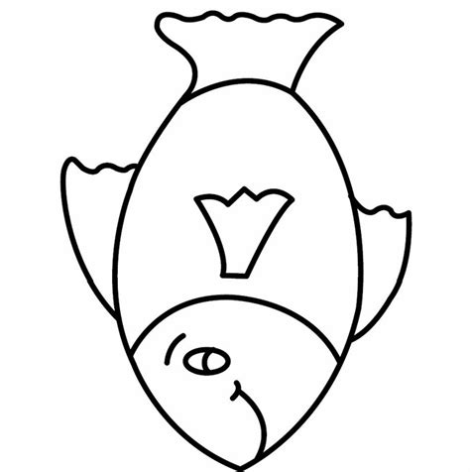
1
2
3
40
3
1
Answers

1 storm fish
2 asked to go to Ninevah (second time)
3 days to walk city days and nights in fish
40 days before God overthrows city

Who repented? Jonah, Ninevites, King of Nineveh
Who was God compassionate to? Sailors, city, king, Jonah
Name all who were obedient in this story. Fish, Jonah, city
According to Jonah 2:2 what does God do when we pray? He answers us.

