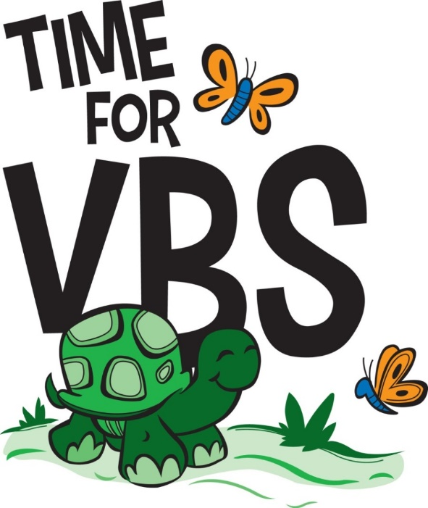
Help! I’m the VBS Director! What Do I Do?

Create specific job descriptions for all involved so that they know what is expected of them and to prevent duplication or overlap of responsibilities.

- Teachers
- Music
- Crafts
- Snacks
- Recreation
- Supplies
- Group leaders for opening and closing sessions

Consider how to encourage and invite people to come to VBS.

Clarify why we teach – to proclaim the Gospel (not just fun and games). The Word of God has supernatural power. The most important preparation of the teacher is the spiritual preparation.

Establish some specific goals for the week: What do we want students to come away with by the end of the week? What truths are important for them to know?

Encourage teachers and leaders. God is able to use all our gifts for His glory. But God is the One who creates and nurtures spiritual life and growth, and He uses us in spite of our weaknesses. One plants, another waters, but God causes the growth. When we are sharing God’s Word, He is at work in the hearts of our students even when we can’t see it.

Be Prepared. Nurture your own personal spiritual life, spend time in prayer, get to know students (be familiar with age, background, etc.), know what is expected of you, and plan and prepare tasks thoroughly.

Talk through some of the lessons as leaders. Establish together what the main theme of each lesson is to help the lessons and daily activities stay focused.

If you won’t have all the materials right away, consider having all leaders read and study the Bible texts for the lessons in their devotional times the next few weeks or months in preparation for VBS.

Equipping volunteers to teach and lead is an essential part of getting ready for your VBS program! Having weekly meetings leading up to VBS is an excellent opportunity for gathering to pray, discuss goals, and prepare for a VBS that teaches kids about Jesus the Savior.

“For God so loved the world, that He gave His only begotten Son,
that whoever believes in Him shall not perish,
but have eternal life.” John 3:16

What’s the Purpose of VBS?
- Proclaim the Gospel – nurture faith in believing children and bring the Good News of salvation to unbelievers.
  - Teach about our sinful condition, and focus on Christ and His love for us. Ask yourself, Where is Christ in this lesson? Keep a balance of sin and grace, Law and Gospel.
  - Encourage daily repentance and faith. God invites us to confess our sins to Him and promises to forgive. He gives His grace and strength to us through His Word.
  - Make everything in VBS count and work towards the goal of proclaiming the Gospel (even crafts, recreation, decorations, etc.). Ask the questions: How will this lesson, this activity, this reprimand, this word puzzle, help this child come to know Jesus and grow in faith in Christ and in service to Him and to others?

- Lead students into the Word of God and help them learn how to use the Bible in their daily lives.
  - Refer to and use your own Bible regularly.
  - Give students opportunities to look up verses and read from the Bible.
  - Encourage students to bring their own Bibles every day. Provide Bibles for any children who do not have one.
  - Help them to become familiar with the Bible so they can use it freely themselves.
  - Share personal experiences that help students to see that the Bible and a growing relationship with Jesus are important for their lives every day.

- Be a testimony to the community – invite neighborhood children to come, and invite families to the closing service where the Gospel is clearly proclaimed.

Okay, What Else Should I Do?
- Explain the curriculum – how it is laid out and how it works together to teach key biblical themes.
- Discipline – be prepared. Know how you will handle students if there are problems (send to supervisor, etc.).
- Think of hypothetical situations (such as a discipline problem) and give leaders helpful ideas on how to handle them.
- Provide ideas for teaching memory verses if needed.
  - Give leaders opportunities to ask questions.
- Do any of the teachers need information on the age group they will be teaching? For example: What are children like at that age? How do they think? What can they understand (social, physical, emotional, intellectual)? See age level characteristics at www.ambassadorpublications.org under Curriculum Teaching Tips.
- Provide information about how children learn – learning styles (visual, auditory, kinesthetic).
- Consider possible projects to focus on during the week:
  - Service projects in the community.
  - Missionary projects – pass out picture cards of missionaries (or choose a specific missionary family), make a CD or video to send to them, make cards or write letters, pray for them that week and send a picture of your class with a note telling them you are praying for them.
  - Take offerings each day and designate for a special project.

Ambassador Publications

AFLC Parish Education
3110 East Medicine Lake Boulevard Minneapolis, MN 55441
Phone: (763) 412-2010 Email: parished@aflc.org
Web: www.ambassadorpublications.org Online Bookstore: www.ambassadorpublications.org/store

